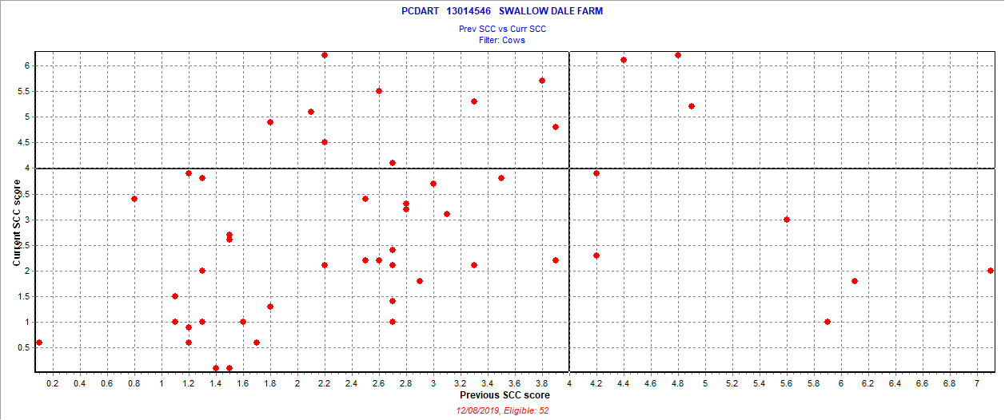

November 29, 2019

New = 9 = 17.3%

Chronic = 3 = 5.8%

Cure = 6 = 11.5%

Uninfected = 34 = 65.4%

Also 2 fresh cows SCC > 3.9